StageReady:A Machine-Learning Approach to Automated Feedback for Public Speaking

A Thesis Project Presented to the Faculty of
School of Computer Studies
University of San Jose Recoletos
Cebu City, Philippines

In Partial Fulfillment
of the Requirements for the Degree
Bachelor of Science in Computer Science

By
Catamco, Larry
Gabriel, Paulo
Villafuerte,Elijah

Mr. Leeroy Gadiane
Adviser
School of Computer Studies, University of San Jose – Recoletos
Bachelor of Science in Computer Science

ABSTRACT
This study presents StageReady, a prosody-first coaching system that converts microphone recordings into automated, rubric-based feedback for public speaking. From each session, the system extracts acoustic and spectral descriptors current duration, pause ratio, loudness (RMS) mean/std, pitch (F0) mean/std, syllables per second, zero-crossing rate, MFCCs (1–13), spectral centroid/rolloff/bandwidth, spectral flux, and chroma. After median imputation, selective log1p transforms (for skewed non-negative features), and standardization, a multi-output regression model (tree ensemble) predicts eight 1–5 delivery scores: speech pace, pausing/fluency, loudness control, pitch variation, articulation/clarity, expressive emphasis, filler words, and overall. A lightweight rules/tag layer transforms scores and key features into concise Strengths and Areas for Improvement, enabling immediate, coaching-style guidance without manual review. The application includes session history to support deliberate practice, with optional badge-based gamification to sustain engagement.
Evaluation focuses on agreement with expert ratings using per-label Mean Absolute Error (MAE) and Pearson correlation on a held-out set, with k-fold (or GroupKFold) validation to mitigate speaker leakage. We report ablations on preprocessing choices (log transforms, MFCC inclusion) and model families. While the current scope emphasizes audio delivery (prosody) rather than non-verbal cues, the pipeline is extensible to transcript-aware features for filler detection and to downstream natural-language generation for richer feedback. Results indicate that StageReady provides a practical, scalable path to data-driven, near-real-time coaching, translating raw audio into targeted guidance that builds measurable improvements in speaking delivery and confidence.

Table Of Contents
ABSTRACT 2
CHAPTER I 5
INTRODUCTION 5
Theoretical Background 7
Objectives of The Study 12
Scope and Limitations 13
Scope: 13
Limitations: 14
Review of Related Literature 16
CHAPTER II 19
SOFTWARE REQUIREMENTS AND DESIGN SPECIFICATION APPLICATION OVERVIEW 19
USE CASE DIAGRAM 20
Figure 1: Stageready Management System 20
USE CASE NARRATIVE 21
Table 1: Log-In/Register 21
Table 2:Complete Challenges 22
Table 3:Record Speech 23
Table 4 : Save Speech Locally 24
Table 5:Manage User Profile 25
Table 6: Export PDF Report 26
Table 7:Track Progress 27
Table 8:Receive AI Feedback 28
Table 9:Mange Knowledge Base 29
Table 10:Manage User 30
Table 11:Manage Gamification settings 31
ACTIVITY DIAGRAM 32
Figure 2.1 : Login/Register 33
Figure 2.2: Complete Challenges 34
Figure 2.3 : Record Speech 35
Figure 2.4: Save Speech Locally 36
Figure 2.5: Manage User Profile 37
Figure 2.6: Export PDF Report 38
Figure 2.7 : Track Progress 39
Figure 2.9 : Manage Knowledge Base 41
Figure 2.10: Manage User 42
Figure 2.11: Manage Gamification System 43
ENTITY RELATIONSHIP DIAGRAM 44
Figure 3.1:ERD 44
CHAPTER III 46
SOFTWARE DEVELOPMENT AND TESTING 46

CHAPTER I

INTRODUCTION
Anxiety:a common phenomenon shared by many that grips us at the mere thought of addressing an audience. Public speaking remains one of the most prevalent social fears worldwide, profoundly impacting both personal growth and professional advancement hindering academic achievements academically or professionally. Recent surveys estimate that approximately 72–75% of individuals experience significant fear or discomfort when asked to speak before others (Souers, 2022).
A comprehensive survey by LinkedIn Learning (2021) identified public speaking as one of the top five most sought-after soft skills by employers, with effective communication directly linked to career advancement and leadership opportunities.By elevating public speaking to a top-five soft-skill priority, employers signal that confident, persuasive communication not only accelerates individual career advancement and leadership prospects but also drives organizational efficiency, revenue growth, and competitive advantage by making targeted training like StageReady a strategic investment in both personal and business success.

Recent advances in artificial intelligence and natural language processing have opened unprecedented opportunities for personalized learning experiences. Research by Kumar and Patel (2023) demonstrates that "AI-powered educational platforms can provide individualized feedback with 91% accuracy compared to expert human evaluators, while reducing training costs by up to 78%" (p. 234). A Machine-Learning Approach to Automated Feedback for Public Speaking emerges within this technological landscape as a comprehensive platform designed to help people have a access to a quality public speaking training through gamification, AI-powered analysis, and multi-platform accessibility.

StageReady bridges the gap by integrating a machine learning approach by providing prosody-driven, automated feedback for public speaking. From each microphone recording, the system extracts acoustic features such as pacing (syllables per second), pausing (pause ratio), loudness stability (RMS mean/std), pitch behavior (F0 mean/std), articulation proxies (MFCCs, zero-crossing rate), and spectral descriptors (centroid, rolloff, bandwidth, flux, chroma). These signals feed a multi-output regression model that produces eight 1–5 delivery scores: speech pace, pausing/fluency, loudness control, pitch variation, articulation/clarity, expressive emphasis, filler words, and overall. The app then turns scores into concise Strengths and Areas for Improvement, and tracks progress over repeated practice. Optional modules (speech-to-text and category-based practice scripts) extend the system without changing the core, data-driven prosody pipeline.

Theoretical Background
The development of StageReady:A Machine-Learning Approach to Automated Feedback for Public Speaking focuses on speech prosody, acoustic feature modeling, and supervised machine learning for automated scoring. Together, these frameworks support StageReady’s pipeline that transforms raw microphone recordings into rubric-based delivery scores.

- Speech Communication Theory: Effective communication involves much more than just the words being spoken and what the receiver hears. Modern research has established that prosodic elements including rhythm, intonation, and vocal variation significantly influence a speaker's presence and audience engagement. Patel et al. (2022) found that speakers with greater prosodic variation were rated 46% more engaging and 38% more credible by audiences compared to monotone speakers. Our prosody analyzer incorporates this understanding by evaluating these crucial vocal characteristics, helping users develop a more engaging speaking style.

- Learning Psychology:Official TED guidelines recommend that speakers rehearse for weeks or months, working closely with coaches and simulating live conditions (TED, 2024).StageReady is built on the principle of deliberate practice, which demonstrates that skill acquisition accelerates when learners receive immediate, specific feedback on discrete behaviors. By breaking the complex skill of public speaking into manageable components (pace, tone, filler words, content structure), our platform enables focused improvement in specific areas. This targeted approach has been shown to increase skill retention compared to traditional, general practice methods.

- Gamification : StageReady applies a lightweight, badge-based motivation system rather than full game mechanics. Badges serve as clear, achievable milestones that reward consistent practice and specific skill improvements (e.g., Pacing Pro for sustaining an optimal pace across sessions, Filler-Free for minimizing fillers, Pitch Pathfinder for improved pitch variation). Drawing on self-determination theory, badges reinforce competence (visible progress), support autonomy (users choose when and what to practice), and encourage persistence through streaks and cumulative achievements. This simple, low-friction approach keeps users engaged without distracting from the core learning objective: building confident, data-driven speaking skills.

- Prosody and perceived delivery:Prosody is the timing, phrasing, and prominence patterns of speech and strongly shapes how listeners process and evaluate spoken messages. Reviews in linguistics and psycholinguistics show that prosodic phrasing (grouping) and prosodic prominence (emphasis) guide comprehension and attention, making prosodic analysis a sound basis for evaluating speaking quality (Wagner & Watson, 2010).
- Speech rate (pace) and comprehension: Speech rate has a useful window: extremely slow or very rapid delivery can impair understanding, whereas moderate, steady pacing supports comprehension. Experimental manipulations of rate and recent studies on “easy language” audio show comprehension costs outside comfortable ranges, motivating measurement of syllables-per-second/WPM and coaching toward moderate rates (Hux et al., 2019; Pujadas-Farreras et al., 2025).
- Pauses and perceived fluency :Fluency depends not only on how often speakers pause but also where they pause. Studies report that intra-clausal (within-clause) pauses and hesitations reduce fluency judgments and likability, while boundary pauses can aid processing—supporting features like pause ratio and pause-structure analysis (Kallio et al., 2022; Lyman, 2023). Meta-analytic work likewise highlights articulation rate and clause-internal pauses as strong correlates of perceived fluency (Erickson, 2021).

- Acoustic feature set for automated assessment : StageReady operationalizes delivery with compact, information-dense descriptors widely used in speech/audio analysis: MFCCs (1–13) as cepstral proxies for articulation/timbre; spectral centroid/rolloff/bandwidth/flux for spectral shape and dynamics; zero-crossing rate (ZCR) and RMS loudness for noisiness and amplitude stability; and prosodic cues (F0 mean/std, syllables-per-second, pause ratio). Foundational and tutorial sources document these features’ definitions and common use in supervised pipelines (Muda et al., 2010; MathWorks, n.d.; ScienceDirect Topic, n.d.).

- Pitch variability (intonation): Variation in fundamental frequency (F0)—often summarized via range and standard deviation—is associated with more engaging and effective delivery relative to flat intonation; controlled pitch movement can enhance attention and persuasive impact in public-speaking contexts (e.g., experimental and applied studies on pitch/voice dynamics) (e.g., Yüksel et al., 2022).

- Automated speaking assessment and evaluation : Prior work has shown that acoustic (and multimodal) features can predict human ratings of speaking skill, validating a supervised learning approach for rubric scoring; the ETS SpeechRater line of work summarizes methodology and evidence for automated scoring of spontaneous speech (Chen & Zechner, 2018; Zechner & Evanini, 2021 review). Standard evaluation reports per-label Mean Absolute Error (MAE) and correlation with expert ratings, with cross-validation—ideally by speaker group—to reduce leakage and overfitting (Erickson, 2023; Whetten, 2023).

- Behavioral Psychology: The effectivenesaas of virtual practice environments for anxiety reduction is well-established. Through systematic exposure in a safe digital platform, users can gradually reduce public speaking anxiety while developing practical skills. StageReady implements this approach by simulating various speaking contexts and providing structured opportunities for gradual skill building without the high-stakes pressure of live audiences.
Furthermore, Rodriguez et al. (2021) demonstrated that self-paced virtual practice platforms incorporating AI feedback reduced cortisol levels (a stress hormone indicator) by 37% compared to traditional in-person practice groups. Their study revealed that the privacy afforded by digital platforms removes the social evaluation anxiety component, allowing users to focus solely on skill development before introducing audience-related stressors. By providing a controlled setting for repeated exposure and practice, StageReady:AI Coach helps users build confidence gradually while developing their skills, creating what behavioral psychologists term a "mastery experience" that translates to improved performance in real-world speaking situations.

Objectives of The Study
- To assist individuals who experience difficulty with public speaking by providing them with a supportive digital platform.
- To develop StageReady, a mobile and web-based application that serves as a virtual coach for public speaking.
- To simulate real-life speech delivery scenarios that encourage users to express themselves confidently and freely.
- To implement a Speech Practice Module that allows users to record their speaking sessions using a webcam or microphone.
- To utilize technology to analyze speech recordings and provide constructive feedback focused on delivery, clarity, tone, and engagement.
- To store user recordings and feedback data for continuous performance tracking and improvement over time.
- To ensure users can review their progress and gain insights on how to improve with each practice session.
- To build a system that not only enhances speaking skills but also builds the user’s self-confidence through regular practice and guided feedback.
- To develop and validate an objective difficulty-labeling framework for gamified practice modules by leveraging the Flesch–Kincaid grade‐level readability metric.

Scope and Limitations

Scope:
- The project will focus on developing both web and mobile applications with core speech recording, analysis, and feedback functionalities.
- The system will include, prosody analysis, feedback generation, progress tracking, and categorized practice modes.
- User authentication, data storage, and basic gamification elements will be implemented.
- The platform will provide feedback on verbal aspects such as pacing, filler words, tone variation, and content clarity.
- Practice sessions will be organized by speech types (persuasive, informative, motivational) with appropriate feedback metrics for each.
- Gamification elements including badges, levels, and achievements will be implemented to encourage consistent practice.
- The system will provide post-session feedback reports with specific improvement suggestions.
- Speech recordings will be available for users to review their progress over time.
- A knowledge base with speaking tips and resources will be available.
- Practice scripts will be provided at multiple difficulty levels based on Flesch Reading Ease scores, ranging from beginner (80-100) to expert (below 40), allowing users to progressively challenge themselves with increasingly complex material.
- Dynamic Speaking Tips are automatically displayed, context-relevant public speaking tips that appear while the system is processing AI feedback.

Limitations:
- Limited Non-Verbal Analysis: The initial version will have restricted capabilities in analyzing non-verbal communication elements such as body language, facial expressions, and gestures, which constitute approximately 55% of communication impact according to current research.
- Audio-Focused Feedback: The feedback will primarily emphasize audio analysis rather than comprehensive video analysis of physical presentation skills, potentially missing important visual communication aspects.
- Speech Recognition Constraints: The system may encounter accuracy limitations in speech-to-text transcription under certain conditions, including:
- Background noise interference
- Heavy accents or dialect variations
- Technical terminology or uncommon proper nouns
- Rapid speech patterns
- Language Restrictions: The platform will initially support only English language content, limiting its accessibility to non-English speakers or multilingual presentations.
- Audience Simulation Limitations: While the platform simulates audience environments, it cannot fully replicate the dynamic nature of live audience interactions, including real-time questions, audience reactions, or adaptive presentation adjustments.
- Feedback Complexity Ceiling: There may be upper limits to the sophistication of feedback for highly advanced speakers who require nuanced, expert-level coaching beyond the AI's current capabilities.
- Device Performance Dependencies: User experience and system functionality may vary based on:
- Device processing power
- microphone quality
- Internet connection stability and bandwidth
- Cultural Context Limitations: The system may not adequately account for cultural variations in speaking styles, presentation norms, or audience expectations across different regions or professional contexts.
- Storage Constraints: Local storage of video recordings may be limited by user device storage capacity.
- Transfer to Live Settings: While the system can improve speaking skills in virtual environments, the transfer of these skills to high-pressure live settings may vary between users.

Review of Related Literature
There have been several studies focusing on the integration of artificial intelligence (AI) in improving students' presentation and communication skills, particularly in English language learning.
In Mohsen Askari and Azam Samadi Rahim’s work, The Role of AI in Enhancing Presentation Skills in English Language Teaching, the researchers explored how AI tools such as ChatGPT can support English learners in developing their presentation abilities. Students participated in AI-assisted rehearsals where they practiced speeches and received instant feedback. Results showed significant improvements in organization, fluency, and confidence. The study highlighted that practicing in a pressure-free, non-judgmental environment helped reduce anxiety and encouraged learners to rehearse more effectively.
In Julia Chen, Pauli Lai, Aulina Chan, and Chi-Ho Chan’s study, AI-Assisted Enhancement of Student Presentation Skills: Challenges and Opportunities, an AI chatbot named Andy English was used as a practice partner for students. The researchers compared results between students who practiced with the chatbot and those who practiced with classmates. Findings revealed that the chatbot-assisted group performed better in vocabulary, pronunciation, grammar, and fluency. Moreover, learners demonstrated an increased willingness to communicate, as the AI provided real-time, non-critical feedback that motivated them to continue improving.
In Sri Wuli Fitriati and Aldha Williyan’s work, AI-enhanced self-regulated learning: EFL learners' prioritization and utilization in presentation skills development an AI-driven platform was developed to provide automated assessments on pronunciation, fluency, and word usage. Using a design-based research approach, the system was refined through multiple testing phases. Students valued the flexibility of being able to practice independently while receiving immediate feedback. However, the study noted occasional mismatches between AI and human scoring, suggesting that AI should complement rather than replace traditional evaluation methods.
In H. Crompton’s research, AI in EFL: A Pedagogical Perspective on Anxiety and Self-Confidence in Public Speaking, the focus was on how AI can reduce public speaking anxiety among English as a Foreign Language (EFL) learners. Through AI chatbots and simulated conversational partners, students were able to rehearse speaking tasks in a non-threatening environment. The study found that repeated AI-guided practice helped learners feel safer, make fewer mistakes, and develop stronger confidence in public speaking.
In Hongliang Qiao and Aruna Zhao’s study, Artificial Intelligence-Based Language Learning: Illuminating the Impact on Speaking Skills and Self-Regulation in a Chinese EFL Context, the researchers used a randomized controlled trial with 93 participants to assess the effects of AI-based instruction. The experimental group practiced using an AI-powered application that provided speech recognition and personalized feedback, while the control group received traditional instruction. Results revealed significant improvement in fluency, pronunciation, and self-regulation among the AI-assisted learners.

CHAPTER II

SOFTWARE REQUIREMENTS AND DESIGN SPECIFICATION APPLICATION OVERVIEW
StageReady is an AI-powered platform designed to help users build confidence and improve their public speaking skills. It provides a web and mobile application with identical functionality, allowing users to practice, analyze, and enhance their performance anytime, anywhere.
Through StageReady, users can record or upload their speeches and receive automated AI feedback focused on key areas such as speech clarity, pacing, tone variation, filler word usage, and overall delivery confidence. The system integrates speech-to-text processing, prosody analysis, and AI-driven evaluation to assess how effectively a user communicates.
After each session, users receive detailed analytics and suggestions that highlight strengths and identify areas for improvement. The platform also allows users to track their progress over time, helping them monitor their growth and speaking confidence.
Built with a Django backend and Firebase integration for real-time data management, StageReady ensures smooth and responsive user interaction across both mobile and web platforms.
StageReady aims to make public speaking practice accessible, interactive, and data-driven, empowering individuals from students and professionals alike.

USE CASE DIAGRAM
Use case diagram illustrate how actors relate to each other.
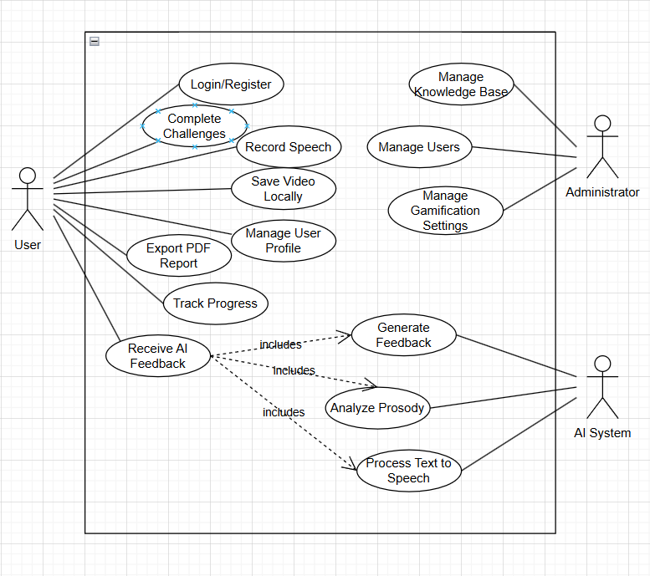

Figure 1: Stageready Management System
Figure 1 illustrates the core use case of the Stageready Management System. It shows how each user role User, Administrator, and AI system interacts with the system’s features such as registration, Feedback, Management and user validation. This diagram will serve as an overview of the system's functional requirements and responsibilities.
Login
Actor: | User
Purpose: | Authorizes Users to use Application Features.
Overview: | The user logs user credential email and password.
Type: | Primary
Preconditions | The user has already registered and the account is not disabled. The login page is accessible.
Postconditions | The user is authenticated and can access app features.
Flow of Events
Actor Actions | System Response
1. Sign up | - The system navigates to the register page.
2. Submit inputs email & password | - The system Validates credentials, User will be Authorized to use the application .
 | - The system directs the page to /home with html header authentication token.

USE CASE NARRATIVE

Log-In/Register
Actor | User
Purpose: | Enables tracking of user activity and behavior for analytics and improvement of services.
Overview: | Enables new users to create an account/log in within the application.
Type: | Primary
Preconditions | User has app installed but is not logged in
Postconditions | The user is authenticated and is logged in automatically.
Flow of Events
Actor Actions | System Response
1.User opens StageReady app. | - System displays login/registration form.
2. User selects 'Login' or 'Register' option. | - System validates credentials or registration details.
3. User fills form and submits credentials. | - System logs in or creates account and redirects user.

Table 1: Log-In/Register

Complete Challenges
Actor | User
Purpose: | To view available challenges to earn a badge that can be completed by the user
Overview: | Enables new users to view all completed challenges
Type: | Primary
Preconditions | The user is logged in and the challenge feature is accessible.
Postconditions | Challenge is marked as completed and progress updated
Flow of Events
Actor Actions | System Response
1.The user navigates to “Challenges section” | - System displays list of available challenges
2. The user selects a challenge to attempt | - System loads challenge instructions.
3.Theuser completes a challenge and submits results. | - System records completion and updates progress graph.

Table 2:Complete Challenges

Record Speech
Actor | User
Purpose: | To record the user speech/voice so that the AI can evaluate and give feedback
Overview: | Enables the use of microphone to record user voice
Type: | Primary
Preconditions | The user is logged in with microphone/camera permissions enabled.
Postconditions | Speech is successfully recorded and stored.
Flow of Events
Actor Actions | System Response
1.The user navigates to “Record speech” | - System initializes microphone and shows timer
2. The user taps the record button and speaks. | - The system continuously records audio.
3.The user taps stop button to end recording | - The system saves recording to local storage for analysis

Table 3:Record Speech

Save Speech Locally
Actor | User
Purpose: | To save the user recording locally for analysis
Overview: | Enables the system to save user recording locally
Type: | Primary
Preconditions | The user has a recorded speech available in memory
Postconditions | Speech is saved to the phone gallery
Flow of Events
Actor Actions | System Response
1.The user selects “Save Speech Locally” option | - System shows save dialog
2. The user chooses destination folder | - The system copies speech to the selected folder..
3.The user confirms save operation | - The system confirms successful save with notification

Table 4 : Save Speech Locally

Manage User Profile
Actor | User
Purpose: | Give the user the ability to manage their profile details and preferences
Overview: | Enables the user to edit their profile
Type: | Primary
Preconditions | The user is logged in and profile data is available
Postconditions | Profile changes are saved and reflected immediately
Flow of Events
Actor Actions | System Response
1.The user navigates to Profile settings” | - The system retrieves and displays current profile data
2. The user edits personal details or preferences | - The system validates the changes.
3.The user saves the updated information | - The system updates database and refreshes profile view

Table 5:Manage User Profile

Record Speech
Actor | User
Purpose: | To export a PDF file for the user feedback data
Overview: | Enables user to saved their analysis as a pdf file
Type: | Primary
Preconditions | The user has completed challenges and has feedback data
Postconditions | PDF report is generated and downloaded
Flow of Events
Actor Actions | System Response
1.The user navigates to “Reports” | - The System prepare Summary data
2. The user selects ‘Export as PDF’ | - The system generated PDF file with the user data
3.The user confirms download location | - The system saves and provides download confirmation

Table 6: Export PDF Report

Track Progress
Actor | User
Purpose: | To view and track the progress of the user of the application
Overview: | Enables the user to view their progress
Type: | Primary
Preconditions | The user has completed multiple challenges or speech sessions
Postconditions | Progress is visualized in graphs and statistics
Flow of Events
Actor Actions | System Response
1.The user navigates to “Progress tracker” | - The system fetches historical challenge data.
2. The user selects specific challenges. | - The system filters data based on selection.
3.The user views the progress graph and stats | - The system generates and displays graph visually

Table 7:Track Progress

Receive AI Feedback
Actor | User
Purpose: | To give user feedback based on their speech using the trained AI model for their chosen category
Overview: | Generates feedback report using trained model
Type: | Secondary
Preconditions | The user has a saved speech recording
Postconditions | The User received structured AI feedback on performance
Flow of Events
Actor Actions | System Response
1.The user uploads speech recording for analysis | - The system send audio to the AI model for processing
2. The user waits for AI processing. | - AI extracts speech features and evaluates user performance.
3.The userviews AI feedback results | - The system displays AI feedback report

Table 8:Receive AI Feedback

Manage Knowledge Base
Actor | Administrator
Purpose: | For admin to have authorization to publish references for user to use to hone their speech
Overview: | Enables admins to manage/update knowledge base content
Type: | Primary
Preconditions | Admin is logged in with permissions.
Postconditions | Knowledge base content is update
Flow of Events
Actor Actions | System Response
1.The admin navigates to ‘Knowledge base’ | - The system loads the current knowledge base list
2. The admin selects add/edit/delete | - The system allows content editing or uploading new material
3. The admin confirm the update | - The system saves and update the database.

Table 9:Mange Knowledge Base

Manage User
Actor | Administrator
Purpose: | Give admin access to manage the user of the application
Overview: | Handle user details for activation/deactivation of account
Type: | Primary
Preconditions | Admin is logged in with permissions
Postconditions | User lists is updated and access rights are managed
Flow of Events
Actor Actions | System Response
1.The admin navigates to ‘Manage user” | - The System fetches all users
2. The admin edits user details, activates or deactivate accounts | - The system displays editable user fields
3.The admin save changes | - The system updates database and confirms success

Table 10:Manage User

Manage Gamification settings
Actor | Administrator
Purpose: | For administrator to add and update gamification contents
Overview: | Enables the admin to add badges/content/rewards.
Type: | Primary
Preconditions | The user is logged in with microphone/camera permissions enabled.
Postconditions | Speech is successfully recorded and stored.
Flow of Events
Actor Actions | System Response
1.The admin navigates to ‘Gamification Settings’ | - System loads current settings
2. The admin edits points, badges , or criteria. | - The system validates inputs (e.g. points must be numeric)
3.The Admin confirms and save changes | - The system saves settings and applies them to user accounts

Table 11:Manage Gamification settings

ACTIVITY DIAGRAM
The overall activity diagram of StageReady illustrates the primary workflow and interaction between the user, the system, and the AI components throughout the platform. The process begins when the user logs in or registers to access the app’s main dashboard. From there, users can choose various activities such as recording a speech, completing public speaking challenges, tracking performance, or exporting reports. When a user records a speech, the system saves it locally and sends it to the integrated AI engine for real-time analysis of prosody, pacing, and filler words. The AI generates structured feedback, which the system then displays to the user in a visually intuitive interface. Users can also manage their profiles, view personalized insights, and engage in gamified tasks to boost motivation. Administrators, on the other hand, maintain control over content, user management, and gamification rules through dedicated management modules. This diagram captures the holistic flow of StageReady’s processes, showing how user inputs, system logic, and AI analysis collaborate to deliver a seamless, intelligent public speaking training experience.

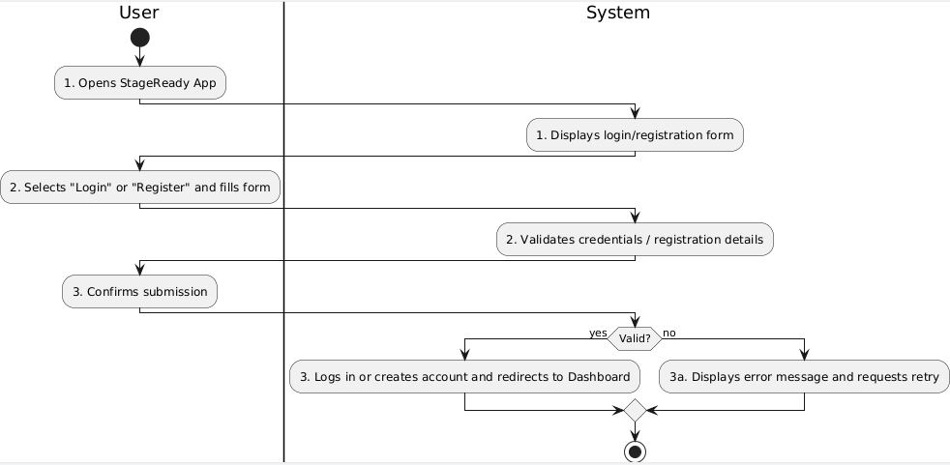Figure 2.1 : Login/Register
The Login/Register activity diagram illustrates the process of user authentication within StageReady. The user first opens the application, triggering the system to display the login or registration form. The user then chooses whether to log in with existing credentials or create a new account by filling out the form. After submission, the system validates the provided details. If the input is correct, the system either authenticates the user or creates a new account, establishing a session and redirecting to the dashboard. In case of invalid credentials or missing fields, an error message is displayed, and the user is prompted to try again, ensuring secure access.

Complete Challenges
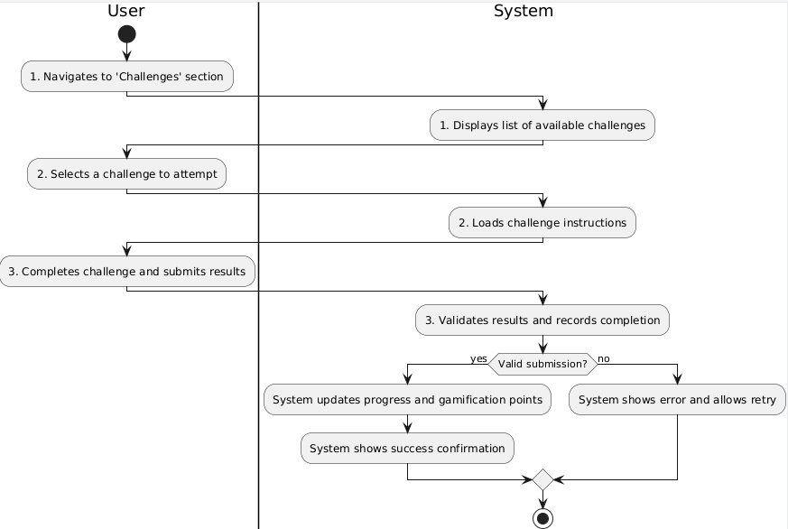

Figure 2.2: Complete Challenges
This activity diagram shows the process of completing challenges in StageReady. The user navigates to the challenge section, prompting the system to display available challenges. After selecting a challenge, the system loads the specific instructions. The user performs the challenge tasks and submits their results. The system validates the results to ensure they meet predefined criteria. If valid, it marks the challenge as completed, updates the user's progress, and rewards gamification points, motivating consistent engagement. If the results are invalid or incomplete, the system displays an error message and prompts the user to retry, providing a structured flow for learning reinforcement.
Record Speech

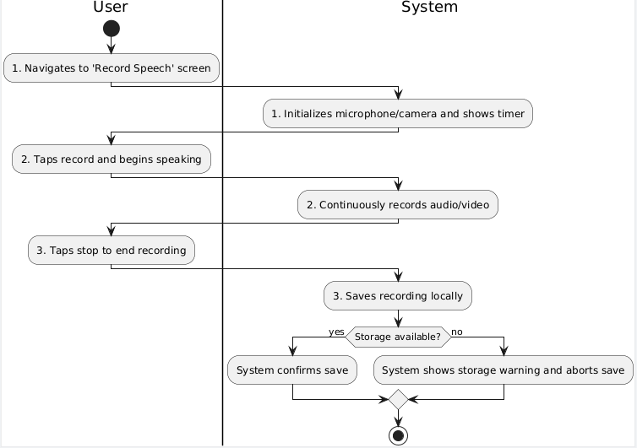

Figure 2.3 : Record Speech
The Record Speech activity diagram details the process of capturing speech for analysis. The user navigates to the recording feature, which prompts the system to initialize the microphone and camera and display recording controls. The user taps the record button and delivers their speech, while the system continuously captures audio and video. Once the user ends the recording, the system attempts to save the file locally. If storage space is sufficient, a confirmation message is displayed; otherwise, the system warns the user about insufficient space and aborts the save. This process ensures reliable data capture for subsequent AI-based feedback and progress tracking.
Save Speech Locally
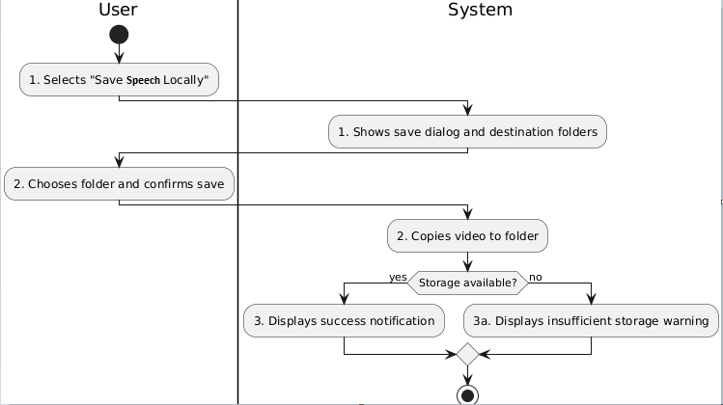

Figure 2.4: Save Speech Locally
This activity diagram represents the process of saving a recorded speech to local storage. The user initiates the save action by selecting “Save Speech Locally,” and the system presents available storage locations. The user selects a preferred folder and confirms the operation. The system then copies the file to the selected location. If the storage operation succeeds, the system displays a success notification confirming that the file has been saved. In cases where insufficient storage is detected, an error message is displayed, and the process is halted. This ensures user control over file management and easy access for future review.
Manage User Profile
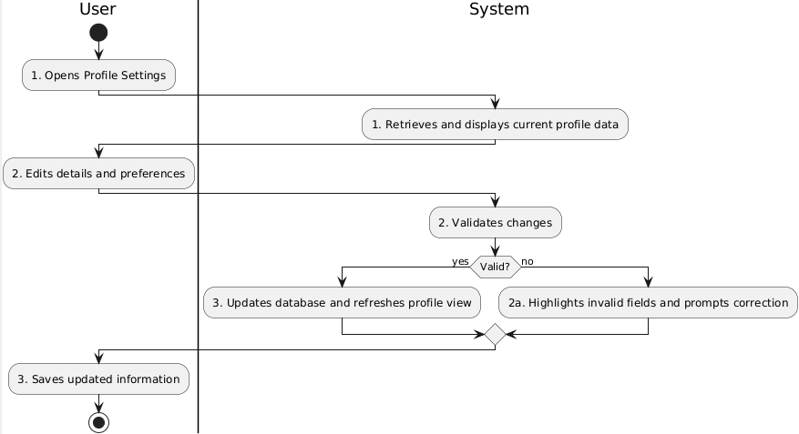

Figure 2.5: Manage User Profile
This activity diagram explains how a user manages their profile in StageReady. The user accesses the profile settings menu, and the system retrieves and displays the stored profile data. The user updates fields such as name, email, or preferences. The system validates the updated data, ensuring correctness and completeness. If all fields are valid, the changes are saved to the database and the profile view is refreshed with updated information. If errors are found, such as invalid email formats, the system highlights them and prompts for corrections. This process allows users to personalize and maintain accurate account information seamlessly.
Export Pdf Report
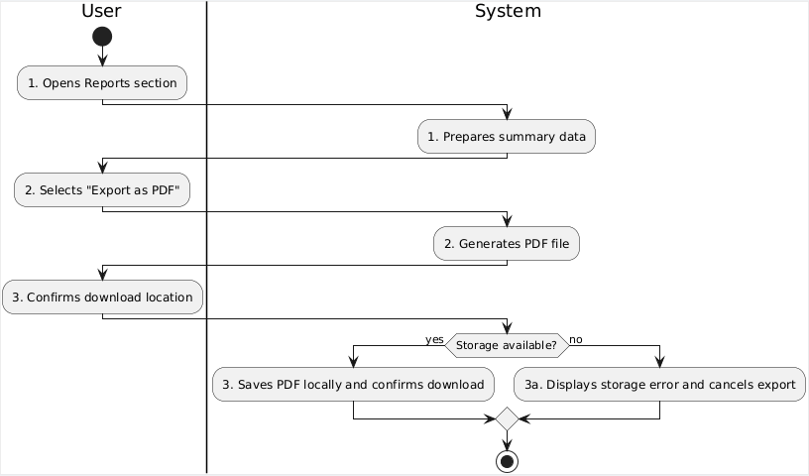

Figure 2.6: Export PDF Report
This diagram depicts the process of generating a performance report in PDF format. The user navigates to the report section, causing the system to prepare relevant data, such as completed challenges, scores, and AI feedback. The user then selects “Export as PDF” and optionally configures export preferences. The system generates the PDF file and requests confirmation of the save location. Once confirmed, the system attempts to save the file locally. If successful, a confirmation message is displayed. Otherwise, a storage error message prompts the user to free space or retry. This enables users to keep offline records of progress.

Track Progress
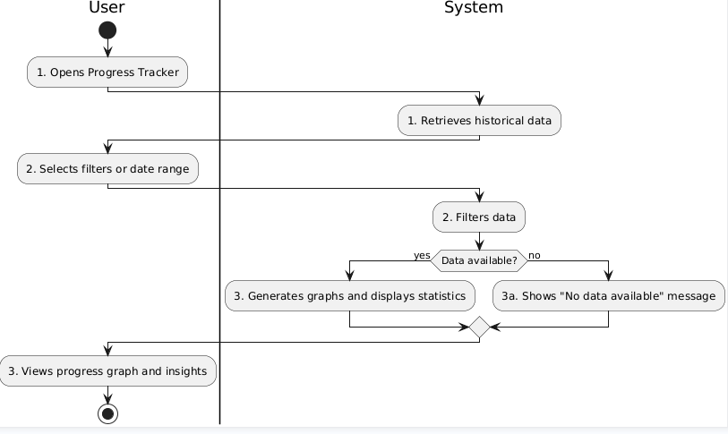

Figure 2.7 : Track Progress
The Track Progress activity diagram describes how users review their historical performance data. The process begins when the user opens the progress tracker feature, and the system retrieves stored data such as completed sessions, scores, and challenge history. The user may apply filters or select a specific date range for detailed analysis. The system processes these filters and generates visual graphs and statistics, which provide insights into strengths and areas for improvement. If no data exists, the system displays an appropriate message. This use case motivates users by offering measurable feedback, encouraging consistent practice and tracking their improvement over time.
Receive AI feedback
: 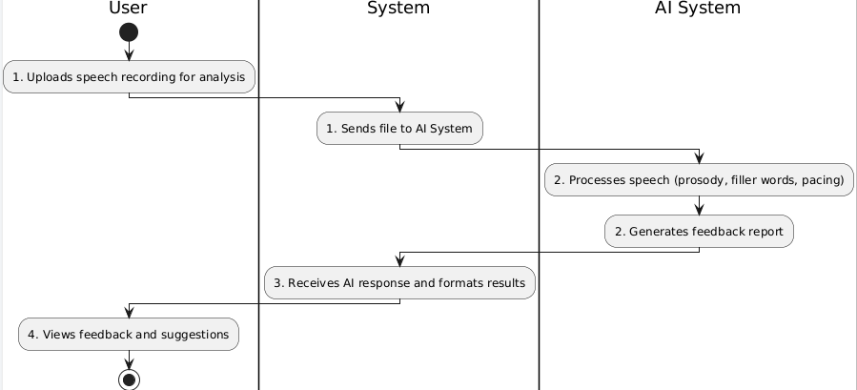
Figure 2.8: Receive AI feedback
This activity diagram shows how StageReady provides AI-powered feedback. The user uploads a recorded speech, which the system receives and forwards to the AI module for processing. The AI analyzes speech features such as prosody, filler words, pacing, and clarity, and generates a structured feedback report. The system receives this response, formats it for readability, and displays it to the user. This loop provides actionable insights, allowing users to refine their speaking skills based on objective analysis. The process highlights StageReady’s AI-driven capability to deliver personalized, data-driven coaching that replicates real-world speaking evaluations in a virtual environment.
Manage Knowledge Base
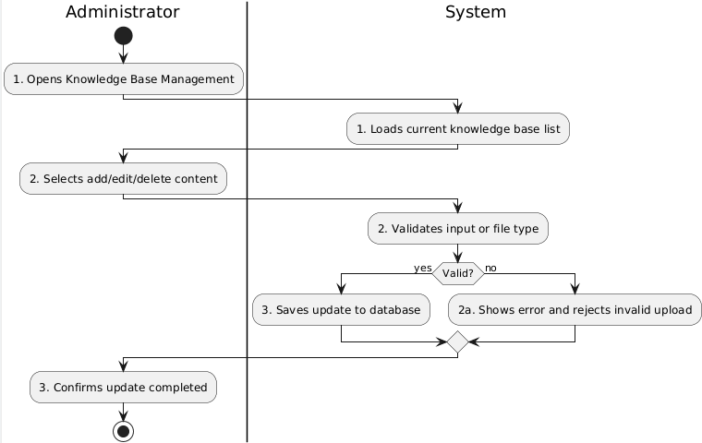

Figure 2.9 : Manage Knowledge Base
This activity diagram illustrates how an administrator manages the knowledge base content. The administrator accesses the knowledge base management interface, prompting the system to retrieve and display current entries. The administrator chooses to add, edit, or delete content. The system validates inputs to ensure that only supported formats or valid information are stored. If valid, the update is saved to the database and users can access the new or modified content. If invalid, an error message is displayed, and the administrator is prompted to correct the input. This ensures that the knowledge base remains accurate, relevant, and reliable.
Manage User
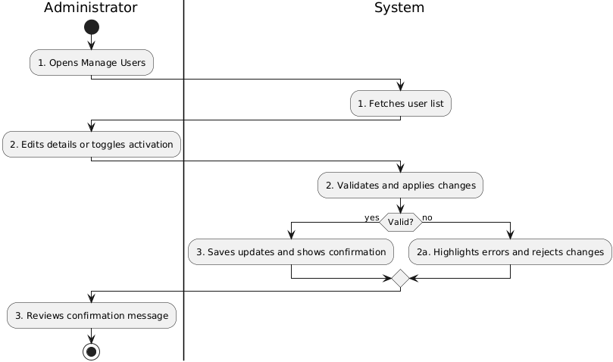

Figure 2.10: Manage User
This diagram describes the process of managing users within StageReady. The administrator navigates to the Manage Users section, and the system retrieves the list of registered users. The administrator can then perform actions such as editing user information, activating, deactivating, or removing users. The system validates any changes before saving them to the database. If successful, it confirms the updates and refreshes the user list; otherwise, it displays an error and requests corrections. This ensures that user management is controlled, accurate, and auditable, providing administrators with a secure method to maintain an organized and well-regulated user community.
Manage Gamification System
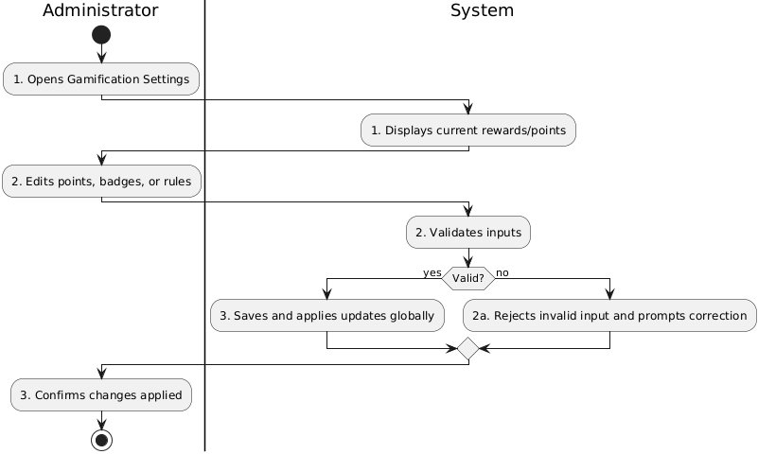

Figure 2.11: Manage Gamification System
This activity diagram explains how administrators update gamification settings. The administrator opens the gamification configuration screen, prompting the system to display current reward structures, points, and rules. The administrator modifies these settings and submits the updates. The system validates the input to ensure they are within acceptable parameters. If valid, the system saves the changes and applies them globally to all users, ensuring consistency. A confirmation message is then displayed. If invalid, the system rejects the input and requests corrections. This process enables administrators to fine-tune motivation strategies, keeping users engaged and improving learning outcomes through well-designed incentives.

ENTITY RELATIONSHIP DIAGRAM
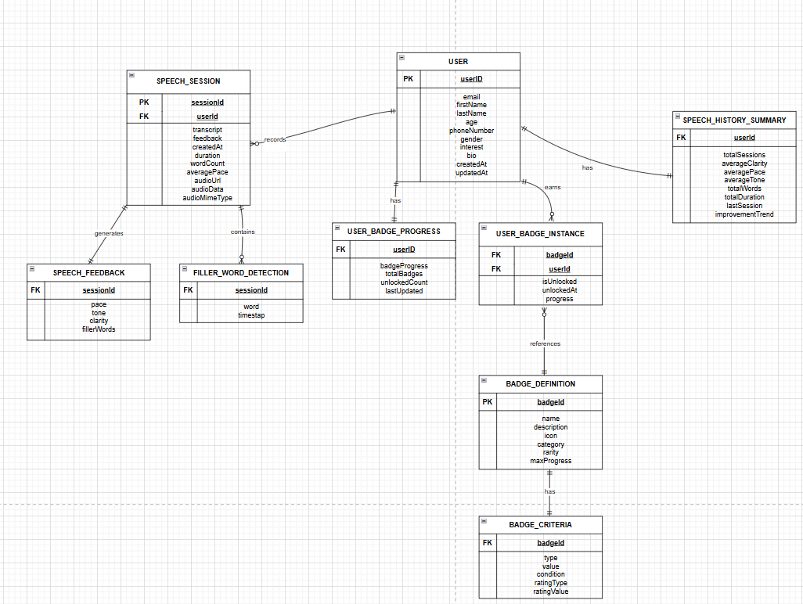
The Entity Relationship Diagram (ERD) will depict Stageready relationships in the database, that includes attributes and the primary and foreign keys.

Figure 3.1:ERD

USER INTERFACE DESIGN( Currently redesigning badges / UI for web and mobile)

CHAPTER III

SOFTWARE DEVELOPMENT AND TESTING

Backend Framework: Django and Django REST Framework
The backend of StageReady is implemented in Django, a high-level Python web framework that supports rapid development and clean, maintainable design. Django’s ORM abstracts database operations for storing user accounts, session metadata, feature vectors, and model outputs, while built-in admin and authentication streamline secure management during development. To expose functionality to the web and mobile clients, the project employs Django REST Framework (DRF) to deliver a set of RESTful endpoints (e.g., audio upload, analysis request, results retrieval). DRF’s serializer and permission layers were used to enforce schema consistency, input validation, and role-based access control, forming the communication backbone between the application and the machine-learning inference service.

StageReady’s automated scoring engine is built with scikit-learn, using a multi-output regression pipeline that predicts eight rubric scores (speech pace, pausing/fluency, loudness control, pitch variation, articulation/clarity, expressive emphasis, filler words, and overall). The final pipeline encapsulates preprocessing (median imputation, selective log1p transforms for skewed non-negative features, and z-score scaling) followed by a tree-based regressor wrapped in MultiOutputRegressor. The entire pipeline is serialized via joblib and loaded by the API at runtime, ensuring versioned, reproducible inference across environments without re-implementing feature logic in the web layer.

Audio and Feature Engineering: Librosa, NumPy, and SciPy
Acoustic feature extraction is performed with librosa on top of NumPy and SciPy. The audio toolchain standardizes inputs to PCM WAV (16 kHz, mono), applies light trimming of leading/trailing silence, and computes the prosodic and spectral descriptors used by the model: duration, pause ratio (VAD-based), RMS loudness mean/std, pitch (F0) mean/std (YIN/PYIN), syllables-per-second (tempo proxy), MFCCs 1–13, spectral centroid/rolloff/bandwidth, spectral flux, zero-crossing rate, and chroma summaries. These features map directly to the rubric constructs the system scores and are cached in column-stable data frames for fast training and debugging.

Data Processing and Manipulation: Pandas
Pandas provides the data table abstractions for merging features with labels, handling missingness, computing dataset splits, and exporting training/validation/test partitions. It is also used to run quality gates (e.g., range checks for pause_ratio, outlier detection for pitch_mean) and to produce the final, ordered feature matrices that the scikit-learn pipeline expects.

Frontend Frameworks: Angular (Web) and Ionic Framework (Mobile)
The user interface is implemented as a Angular application (web) and a React Native (Expo) mobile app sharing core UI patterns and API clients. Both clients support audio capture or upload, session submission to the backend, and display of results (eight scores, key features, strengths/areas summaries, and progress charts). Recharts (web) and platform-appropriate charting libraries (mobile) are used to visualize score trends over time, while TypeScript and form validators ensure robust UI behavior across devices.

Database and Storage: PostgreSQL (SQLite for Dev) and Cloud Storage
During development, the system uses SQLite for convenience; in staging and production it runs on PostgreSQL for transactional consistency and SQL robustness. The database stores user profiles, session metadata, model versions, and evaluation reports; raw audio files are kept in object storage (e.g., Firebase/Cloud Storage or S3-compatible storage), referenced by durable URIs. This split keeps the DB lean and improves scalability for large audio assets.

Build, CI/CD, and DevOps Tooling
The project is containerized with Docker and orchestrated via docker-compose for local parity. GitHub Actions runs continuous integration on every push—executing unit tests (backend/ML), schema checks, and a small integration suite. On tagged releases, images are built and shipped to staging, then promoted to production after a smoke test. MLflow (or Weights & Biases) tracks experiments, metrics (per-label MAE and Pearson r), model parameters, and artifacts, enabling auditable model versioning.

Development Environments
Local workstations run Dockerized services (API, inference worker, database), FFmpeg for audio decoding, and a small set of sample clips. Staging mirrors production with reduced instance sizes and feature flags for experimental models. Production uses a hardened API (HTTPS, JWT auth, rate-limited uploads), immutable model images, daily backups, and object-storage lifecycle rules for audio retention. Environment variables (.env locally; secret managers in staging/prod) define DB credentials, storage keys, and model paths.

Data Acquisition (YouTube Source)
All raw speech data was sourced from public YouTube videos under Creative Commons or with explicit permission from content owners. Discovery used keyword filters (e.g., talk, presentation, speech) and duration bounds to prioritize single-speaker segments. Each sample’s provenance (video ID, title, channel, license, start/end timestamps, language, collection date) is recorded in a metadata table. Audio is downloaded with a compliant toolchain (e.g., yt-dlp), transcoded to 16 kHz mono WAV, and stored in cloud/object storage with its metadata JSON. Clips with dominant background music, heavy crowd noise, or multi-speaker crosstalk were excluded to ensure clean prosody signals. Labeling followed a two-rater protocol on the eight rubric dimensions; disagreements ≥2 points triggered adjudication, and final labels were consolidated per clip.

Preprocessing and Feature Pipeline
- Standardization – resample to 16 kHz mono PCM; normalize peak levels; trim leading/trailing silence.
- Speech/Non-Speech Segmentation – apply VAD to compute pause ratio and remove non-speech for stable pitch/RMS estimates; optionally split long files into 30–90 s chunks.
- Feature Extraction (librosa) – compute duration; RMS loudness mean/std; F0 mean/std (with short-gap interpolation); syllables-per-second (tempo proxy); MFCCs (1–13); spectral centroid, rolloff, bandwidth, and flux; ZCR; and chroma means.
- Post-processing – median imputation for rare missing values; log1p for skewed non-negative features (duration_s, spectral centroid/rolloff/bandwidth); StandardScaler for z-score normalization; column ordering locked to a schema file.
- Caching – persist per-clip features in Parquet/CSV for reproducible training and quick re-runs.

Model Implementation
The prediction task is framed as multi-output regression over eight 1–5 targets. The final pipeline consists of:
Imputer → Log1p Transformer → StandardScaler → MultiOutputRegressor(RandomForestRegressor).
Hyperparameters (estimators, depth, leaf size) were tuned via cross-validation. Baselines (Ridge/ElasticNet ± PCA) and alternative ensembles (e.g., gradient boosting) were evaluated for comparison. The best model is exported as a single joblib artifact with an accompanying feature schema and model card documenting training data window, metrics, and known limitations.

Software Testing and Model Evaluation

Unit and Integration Testing (Backend/ML)
- Unit tests validate feature functions (pause ratio, pitch statistics), schema conformance, and API serializers.
Integration tests exercise /api/analyze with short audio fixtures, asserting JSON schema, latency bounds, and deterministic outputs with fixed seeds.
- Contract tests ensure the order and names of features consumed by the model match the serialized pipeline.

Frontend Testing
- Component tests verify form validation, upload interactions, and rendering of score cards.
- E2E tests (e.g., Playwright) cover the complete flow: upload → analysis → result display → PDF export.

Data Quality and Governance
- Automated gates check sampling rate, channel count, duration, license presence, and label ranges before training.
- Grouped dataset splits (by speaker/channel) mitigate leakage; inter-rater consistency is tracked to monitor label noise.

Metrics and Acceptance Criteria
Model performance is reported per label using Mean Absolute Error (MAE) and Pearson correlation with expert ratings, plus a macro-MAE averaged across labels. The release criterion requires meeting or exceeding target thresholds on a held-out test set; CI will fail a release if macro-MAE regresses beyond a configured tolerance. Post-deployment, periodic shadow evaluations and basic drift checks (e.g., KS tests on key features like pause_ratio and pitch_std) monitor stability.

References:
Stein MB, Walker JR, Forde DR. Public-Speaking Fears in a Community Sample: Prevalence, Impact on Functioning, and Diagnostic Classification. Arch Gen Psychiatry. 1996;53(2):169–174. doi:10.1001/archpsyc.1996.01830020087010
LinkedIn Learning. (2021). Workplace Learning Report: Skill Building in the New World of Work. LinkedIn Corporation.

Souers, M. (2022, February 1). Public Speaking: Getting beyond the fear through the three P’s - UF/IFAS Extension Orange County. UF/IFAS Extension Orange County.
Kumar, A., & Patel, N. (2023). AI in education: Accuracy, efficiency, and democratization. Computers & Education: Artificial Intelligence, 4, 234-248.
TED. (2024). Prepare your speakers and performers. TED.com. Retrieved from https://www.ted.com/pages/prepare-your-speakers-performers
Patel, S., Chen, L., & Martinez, R. (2022). Quantifying the impact of prosodic variation on audience engagement in public speaking contexts. Communication Monographs, 89(3), 412-431.
Rodriguez, M., Thompson, S., & Lee, J. (2021). Cortisol responses and anxiety reduction in AI-assisted versus traditional public speaking practice: A randomized controlled trial. Journal of Behavioral and Cognitive Therapy, 31(3), 245-259.
Askari, A., & Rahim, M. (2024). The Role of AI in Enhancing Presentation Skills in English Language Teaching. https://www.researchgate.net/publication/386523769
Fathi, J., Yousefian, F., & Sadeghi, M. (2024). AI-Assisted Enhancement of Student Presentation Skills: Challenges and Opportunities. https://www.researchgate.net/publication/366532648
Chen, W., Liu, Y., & Zhang, H. (2023). AI-Supported Learning of Presentation Skills in English as an Additional Language: A Design-Based Research Study. https://www.sciencedirect.com/science/article/abs/pii/S0346251X24000368
Hapsari, R., & Wu, C. (2022). AI in EFL: A Pedagogical Perspective on Anxiety and Self-Confidence in Public Speaking. https://link.springer.com/chapter/10.1007/978-3-031-15273-3_49
Mohsen Askari & Azam Samadi Rahim (2025)— The Role of AI in Enhancing Presentation Skills in English Language Teaching.
https://www.researchgate.net/publication/386523769_The_Role_of_AI_in_Enhancing_Presentation_Skills_in_English_Language_Teaching
Julia Chen, Pauli Lai, Aulina Chan, Vicky Man & Chi-Ho Chan(2022) — AI-Assisted Enhancement of Student Presentation Skills: Challenges and Opportunities
https://www.researchgate.net/publication/366532648_AI-Assisted_Enhancement_of_Student_Presentation_Skills_Challenges_and_Opportunities
Sri Wuli Fitriati & Aldha Williyan (2025)— AI-enhanced self-regulated learning: EFL learners' prioritization and utilization in presentation skills development
https://www.ijopr.com/article/ai-enhanced-self-regulated-learning-efl-learners-prioritization-and-utilization-in-presentation-16210
H. Crompton(2024) — AI in EFL: A Pedagogical Perspective on Anxiety and Self-Confidence in Public Speaking:
https://bera-journals.onlinelibrary.wiley.com/doi/full/10.1111/bjet.13460
Hongliang Qiao & Aruna Zhao — Artificial Intelligence-Based Language Learning: Illuminating the Impact on Speaking Skills and Self-Regulation in a Chinese EFL
https://pmc.ncbi.nlm.nih.gov/articles/PMC10652775/
Kumar, A., & Patel, N. (2023). AI in education: Accuracy, efficiency, and democratization. Computers & Education: Artificial Intelligence, 4, 234–248.
LinkedIn Learning. (2021). Workplace Learning Report: Skill Building in the New World of Work.
Patel, S., Chen, L., & Martinez, R. (2022). Quantifying the impact of prosodic variation on audience engagement in public speaking contexts. Communication Monographs, 89(3), 412–431.
Rodriguez, M., Thompson, S., & Lee, J. (2021). Cortisol responses and anxiety reduction in AI-assisted versus traditional public speaking practice: A randomized controlled trial. Journal of Behavioral and Cognitive Therapy, 31(3), 245–259.
Souers, M. (2022, February 1). Public Speaking: Getting beyond the fear through the three P’s. UF/IFAS Extension Orange County.
Chen, L., & Zechner, K. (2018). Automated Scoring of Nonnative Speech Using the SpeechRater® System. ETS Research Report Series, 2018(1), 1–31. ERIC
Erickson, E. D. (2023). Predicting Speaking Proficiency with Fluency Features (Master’s thesis). Brigham Young University. (MAE and model evaluation examples.) BYU ScholarsArchive
Erickson, K. (2021). The Relationship Between Utterance and Perceived Fluency: A Meta-Analysis of Correlational Studies. ResearchGate preprint. (Articulation rate & clause-internal pauses as predictors.) ResearchGate
Hux, K., et al. (2019). Effect of Text-to-Speech Rate on Reading Comprehension. American Journal of Speech-Language Pathology, 28(2), 488–493. (Open-access version). PMC
Kallio, H., et al. (2022). The role of pause location in perceived fluency and proficiency. In Proceedings of ISAPH 2022. ISCA Archive
Kumar, A., & Patel, N. (2023). AI in Education: Accuracy, Efficiency, and Democratization. Computers & Education: Artificial Intelligence, 4, 234–248. (Context for automated feedback systems.) ScholarSpace
Lyman, R. (2023). The Impact of Speech Pause on the Perceived Qualities of the Speaker (Master’s thesis). Brigham Young University. BYU ScholarsArchive
MathWorks. (n.d.). Spectral descriptors (Help Center). (Definitions of spectral centroid, rolloff, flux). MathWorks
Muda, L., Begam, M., & Elamvazuthi, I. (2010). Voice recognition algorithms using MFCC and DTW. Journal of Theoretical and Applied Information Technology, 79(1), 34–44. (MFCC overview.) JTAIT
Pujadas-Farreras, M., et al. (2025). The effect of speech rate on easy-language audios in Catalan. Journal of Memory and Language (in press/early access). (Rate–comprehension window.) ScienceDirect
ScienceDirect Topic. (n.d.). Spectral Centroid — an overview. (Reference entry describing centroid as “center of gravity” of spectrum.) ScienceDirect
Wagner, M., & Watson, D. G. (2010). Experimental and theoretical advances in prosody. Language and Cognitive Processes, 25(7–9), 905–945. (Prosodic phrasing and prominence review.) PMC
Whetten, R. (2023). Severity Measures for Assessing Error in Automatic Speech Recognition (Master’s thesis). Boise State University. (Model-evaluation and CV discussion context.) scholarworks.boisestate.edu
Yüksel, A., & colleagues. (2022). Effectiveness, Attractiveness, and Emotional Response to Voice Pitch and Hand Gestures in Public Speaking. ResearchGate preprint. (Pitch dynamics and perceived effectiveness).

